Part 1
- The light wave shown below meets a boundary between glass and air.
Continue the light ray to show its path after passing the boundary.
- The wave front below is travelling from air into water.
Explain why the wave front bends.
- Complete the sentences.
When light enters a substance of greater density, it will be refracted …………….. the normal line.
When light enters a substance of lower density, it will be refracted ………….. from the normal line.
- What is total internal reflection?

- A vase is illuminated with green and blue light. What colour would the vase appear if viewed through a red filter?

- Which colour of light has the shortest wavelength?

- Copy and complete the ray diagrams .

  - Copy and complete the two light rays on the diagram.
  - Label the principle axis, object and focal length on the diagram.
  - Describe the image produced by the above lens.

- A 12cm object viewed in a convex lens has an image size of 54cm.
Calculate the magnification of the lens.
Part 2
- What type of waves are electromagnetic waves?

- List the main electromagnetic waves in order from lowest to highest frequency.

- Which of the following is the speed of electromagnetic waves in a vacuum?
300 m/s 300 000m/s 300 000 000m/s
- Which colour of light has the longest wavelength?

- Describe one piece of evidence to show that light waves do not need a medium to travel from one place to another.

- The four surfaces below are heated equally with infrared (IR) heat.
  - Which surface will absorb the most IR radiation?

  - Which surface will reflect the most IR radiation?
- The diagrams show three waves travelling from air into different materials.
Which wave will be travelling the slowest?
Physics only
- A black body is:
  - an object that emits no electromagnetic radiation.
  - an object that absorbs all electromagnetic radiation that falls on it.
  - an object that only emits invisible electromagnetic radiation.
  - an object that absorbs all electromagnetic radiation that falls on it and emits no electromagnetic radiation.
- Explain how black body radiation differs from reflected radiation.

- The picture shows a thermal image of a cat. Why can we not see this thermal emission from the cat without using a specialised camera?
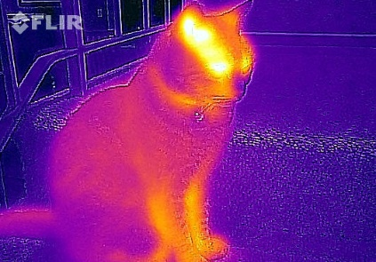
- The stone is in the sunshine and emitting radiation. As the stone heats up through the day, how will the nature of the emitted radiation change?
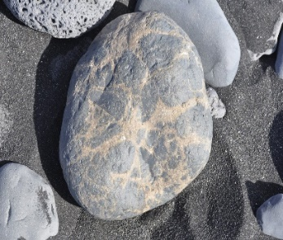

- If a body absorbs radiation at a faster rate than it emits radiation, what change will happen to the body?

- The diagram shows how global warming of the Earth can occur. Explain what is happening in terms of changes to absorbed and emitted radiation.
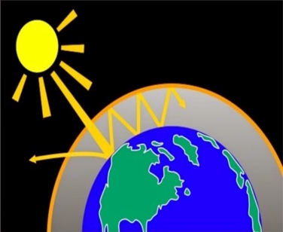
- Which three types of electromagnetic waves can cause damage to cells in the body?

- What is meant by radiation dose?

- The chart shows the average radiation dose a UK person is exposed to in a year.
  - What percentage of the radiation dose comes from natural sources

  - Give two reasons why a person could receive a higher dose of background radiation.

- Complete the table for uses of electromagnetic waves.
Type | Application
Radio
Microwave
Infrared
Visible
Ultraviolet
X-rays
Gamma rays

- (HT) Radio waves are transmitted through the air and received by aerials.

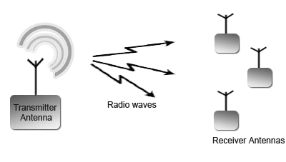

  - How are radio waves produced in the transmitter aerial?
  - What is produced in the receiving antenna when radio waves are absorbed?

- Most electromagnetic waves are produced from energy changes in electron levels. How does gamma wave production differ from this?

